
DTSC-625: Data Engineering

Fine-grained Permission with LakeFormation
Adapted from Eagar, Data Engineering with AWS, 2nd ed., p. 135ff.

With AWS Lake Formation, permissions management is changed so that broad access can be
provided to Glue catalog objects in the IAM policy, and fine-grained access is controlled via AWS Lake Formation permissions. With Lake Formation, data lake users do not need to be granted direct permissions on underlying S3 objects as the Lake Formation service can provide temporary credentials to compatible analytic services to access the S3 data.

It is important to note that Lake Formation permissions access only works with compatible analytic services, such as Amazon Athena, AWS Glue, and others.

If using these compatible services, AWS Lake Formation is a simpler way to manage permissions for your data lake. The data lake user still needs an associated IAM policy that grants them access to the AWS Glue service, the Lake Formation service, and any required analytic engines (such as Amazon Athena). However, at the IAM level, the user can be granted access to all AWS Glue objects. Then, the Lake Formation permissions layer can be used to control which specific Glue catalog objects (databases and tables) can be accessed by the user.
As the Lake Formation service passes temporary credentials to compatible analytic services to
read data from Amazon S3, data lake users no longer need any direct Amazon S3 permissions to be provided in their IAM policies.

Lab Overview
- We will use a Lambda function we created in an earlier lab to write new data to a Glue table.
- We will create an S3 bucket to store our Athena queries.
- We will create an IAM policy to access Glue and Athena.
- We will assign the IAM policy to an IAM user.
- We will verify that the IAM user can use Athena to access the table.
- We will enable our admin user to grant Lake Formation permissions.
- We will grant column-level access to an IAM user.
- We will verify that the IAM user can access only the allowed columns.

Step 1: Convert CSV to Parquet and Load to Glue
In a previous lab, we created a Lambda function to process a CSV. In this lab, we want to consider a new dataset, but we need it to be stored in AWS Glue. We will use the Lambda function to accomplish this for us.

- Download the fictionalPII.csv from Brightspace. This data is fake company data that includes fake personally identifiable information (PII).

- Open the landing-zone bucket we created in an earlier class demo and navigate into the dtsc625-labs folder. Create a new folder called fake_company_data. Navigate into that new folder.

- Upload the fictionalPII.csv into the fake-company-data folder.

- Assuming you completed the previous csv-to-parquet lab successfully, this upload will trigger the Lambda function, store a parquet in your clean-zone bucket, and write the data into a lab (called fake_company_data) in the dtsc625-labs database.

Step 2: Create an S3 Bucket for Athena Results
Now, let’s create a new Amazon S3 bucket that we can use to capture the results of any Amazon Athena queries that we run:

- In the AWS Management Console, use the top search bar to search for and select the S3 service.

- Click on Create bucket.

- For Bucket name, enter dtsc625-<lastname>-athena-query-results. Replace <lastname> with your last name. You may need to use your initials or the term and year if this bucket name is already in use somewhere around the world.

- Ensure AWS Region is set to the region you have been using for the other demos and labs in this class.

- Leave all other options with their defaults, and click on Create bucket.

Step 3: Creating an IAM policy
To start, let’s create a new IAM user that will become our data lake user. We will initially use IAM
to grant our data lake user the following permissions:

- Permission to access a specific database and table in the Glue Data Catalog
- Permission to access specific S3 locations that contain the underlying files associated
with our Glue table objects
- Permission to use the Amazon Athena service to run SQL queries against the data lake

First, let’s create a new IAM policy that grants the required permissions for using Athena and
Glue, but limits those permissions to only the dtsc625-labs in the Glue catalog. To do this, we’re going to copy the Amazon-managed policy for Athena Full Access, but we will modify the policy to limit access to just a specific Glue database, and we will add S3 permissions to the policy.

Let’s get started:
- Log in to the AWS Management Console and access the IAM service:
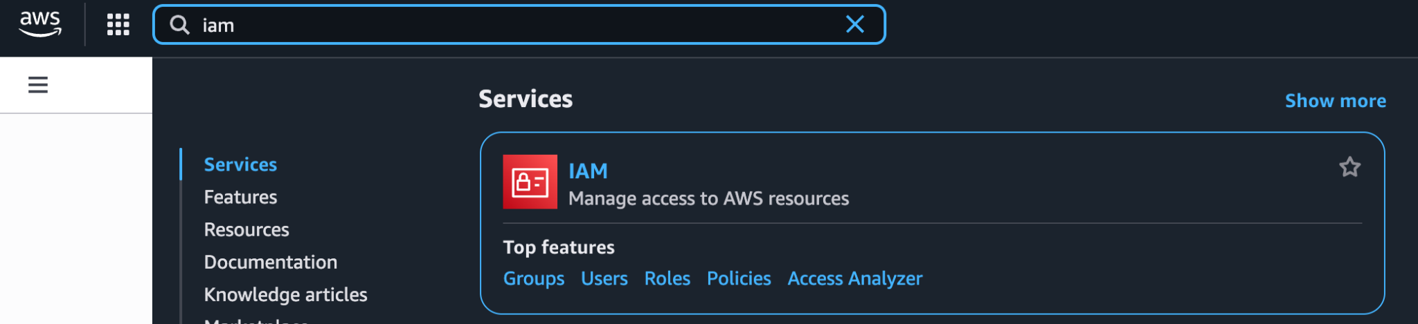

- On the left hand side, click on Policies, and then for Policies, type in Athena and filter by type: AWS managed.
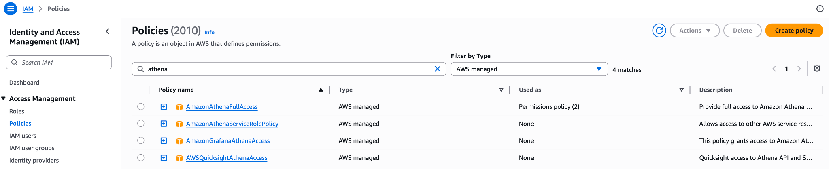

- From the filtered list of policies, expand the AmazonAthenaFullAccess policy by clicking the plus sign.

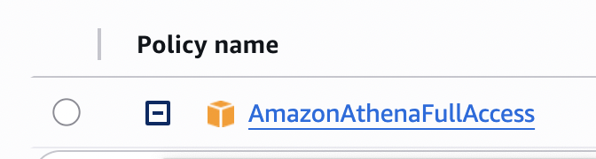
- On the right hand side, click on the Copy JSON button to copy the policy.
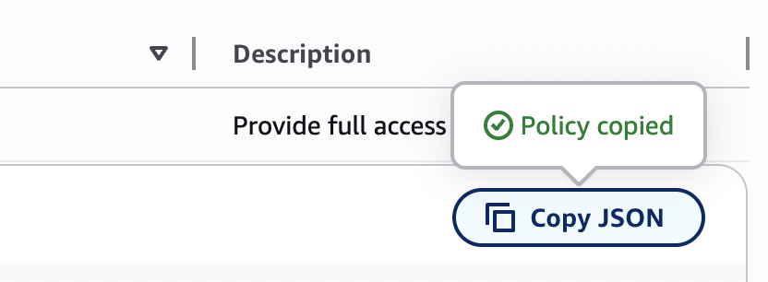

- At the top of the page, click on Create policy.
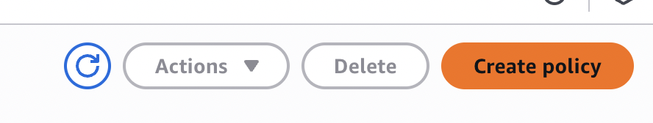

- The visual editor is selected by default, but since we want to create a JSON policy directly, click on the JSON tab.
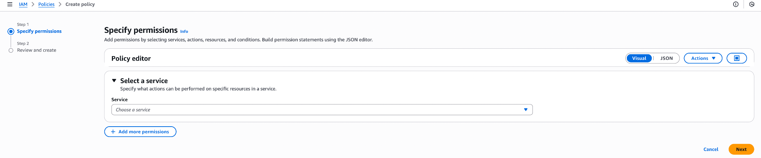

- Delete the provided JSON entirely.
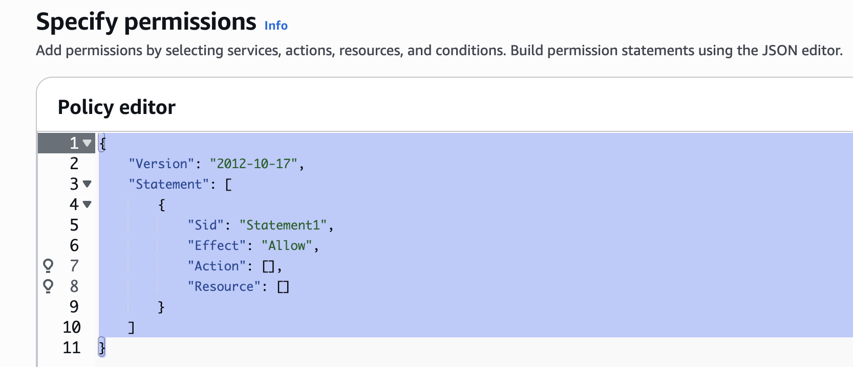

- Paste the Athena Full Access policy that you copied in step 4 into the policy. It’s a lot of text!
- Look through the policy to identify the section that grants permissions for several Glue actions, such as glue:CreateDatabase, glue:DeleteDatabase, etc.
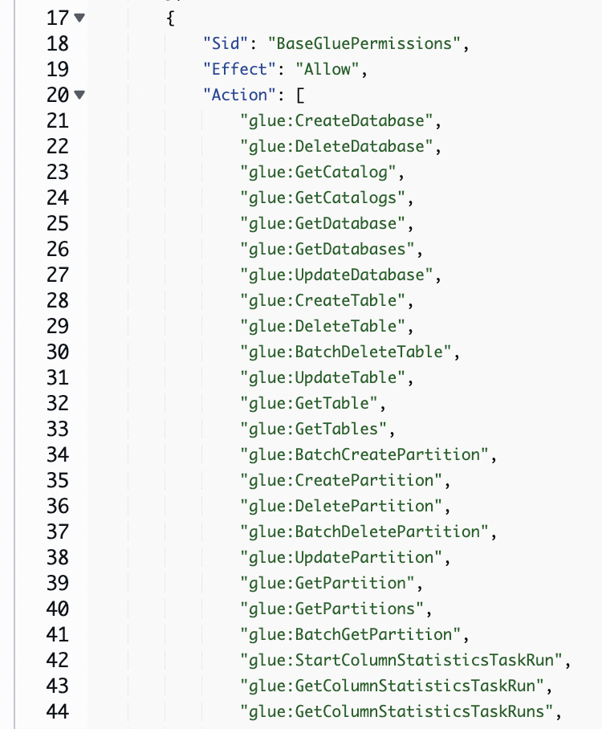

- This section currently lists the resource that it applies to as *, meaning that the user would have access to all databases and tables in the Glue catalog. That is not following the principle of least privilege!
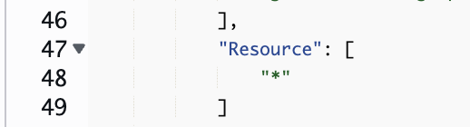

- In our use case, we want to limit permissions to just the Glue dtsc625-labs database, which was created in our csv-to-lambda lab. Replace the “*” in the resource section of the section with the following, which will limit access to the required database only, although it also includes all tables in that database:
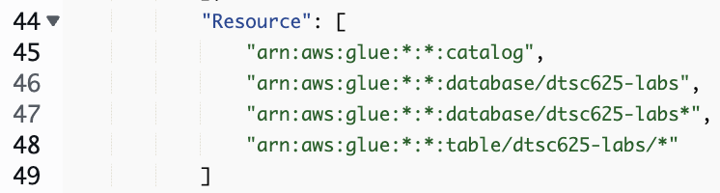

- In the next three sections of the JSON, we can add new permissions for accessing the S3 location where our dtsc625-labs data resides. Add the following section to provide these permissions, making sure to replace the bucket name with the clean-zone bucket you created in an earlier class demo.

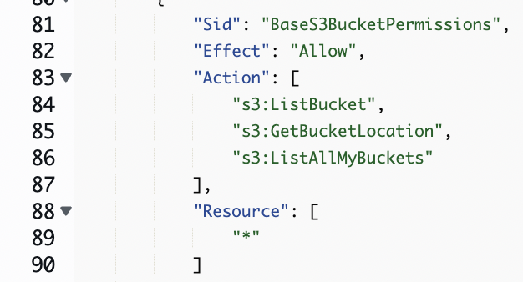
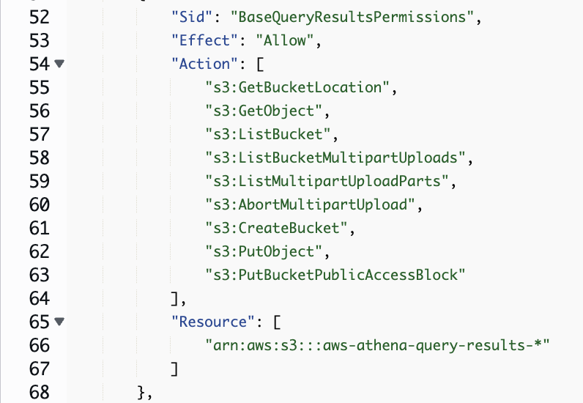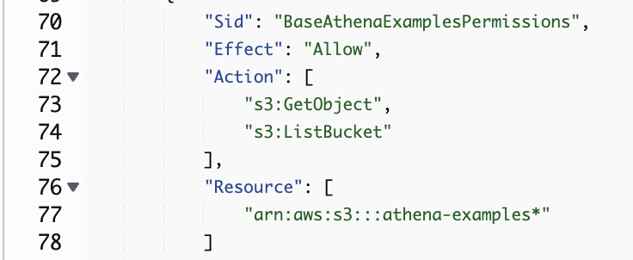

- Update all three with the Amazon Resource Name of your clean-zone bucket: arn:aws:s3:::<name-of-your-clean-zone-bucket>/* and dtsc625-<lastname>-athena-query-results/* Note the /* at the end!

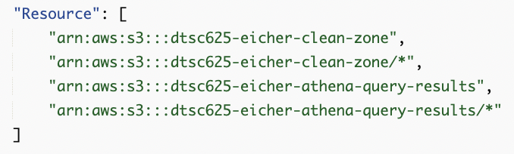
- Once you have pasted in the new S3 permissions, click on Next at the bottom right.

- For Policy name, provide AthenaAccess-dtsc625-labs, and give a description.
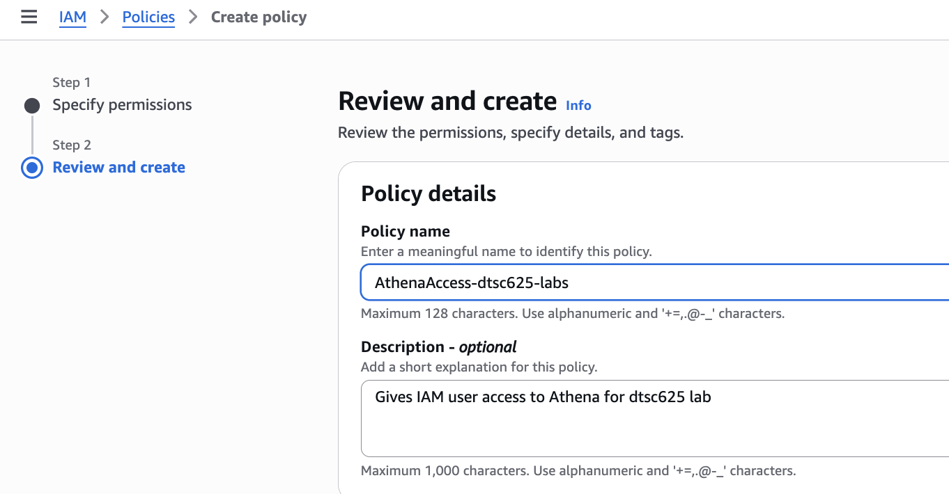

- Scroll down and click Create policy.

Step 4: Create an IAM user
Now that we have created an IAM policy for providing the required permissions to the Glue
catalog and S3 buckets, we can create a new data lake user and attach our new policy to the user. AWS recommends the use of IAM Identity Center to manage users in your account, but for the purposes of this lab, we will make an IAM user in this simpler way.

- In the IAM console, click on Users.
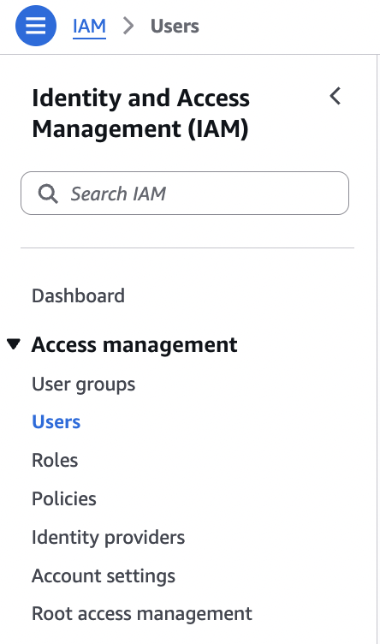

- Click Create user.


- For User name, enter dtsc625-datalake-user. Click the checkbox for “Provide user access to the AWS Management Console - optional.” Make a custom password that you won’t forget, and deselect “Users must create a new password at next sign-in - Recommended”. (In practice, you would autogenerate a password and require them to create their own at the next sign-in.) Select Next.
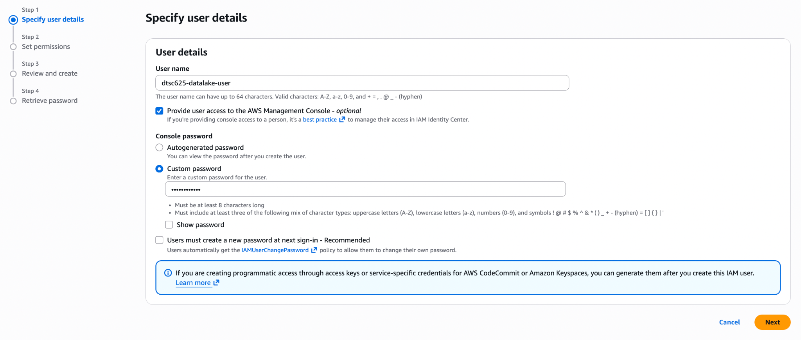

- Under Set permissions, select “Attach policies directly.” (In practice, we would make a datalake-user group and add this user to the group.)
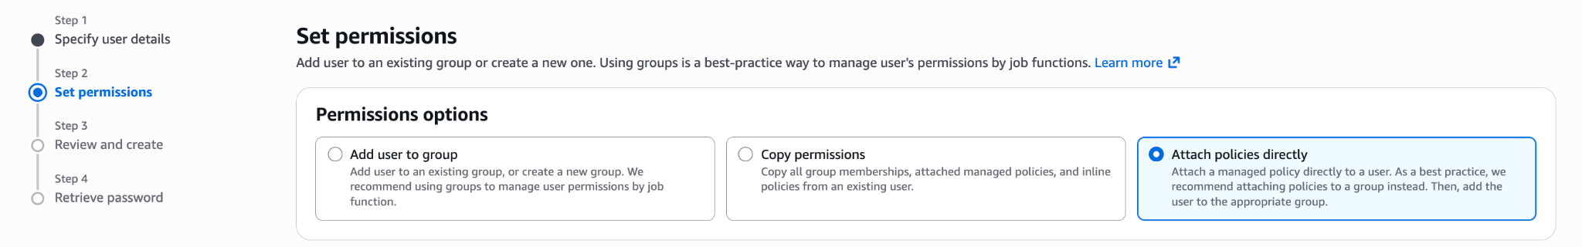

- In the Permission policies search bar, search for 625 and select the AthenaAccess-dtsc625-labs policy that we created above. Click Next.
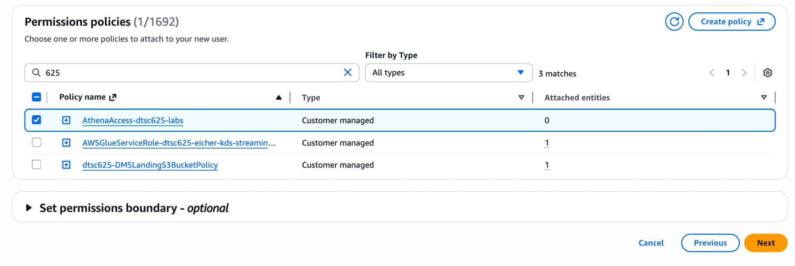

- Review the new user details, add a tag, and then click Create user.
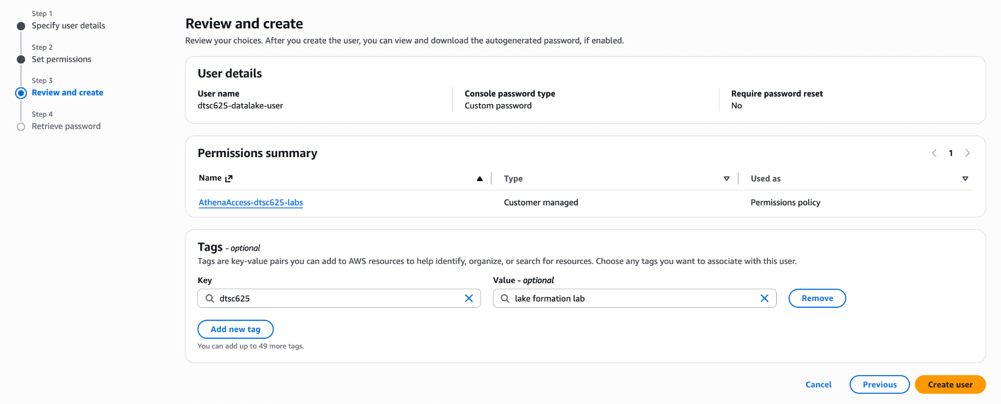
- Take note of the Console sign-in URL, which can be used to access the login screen for your account.
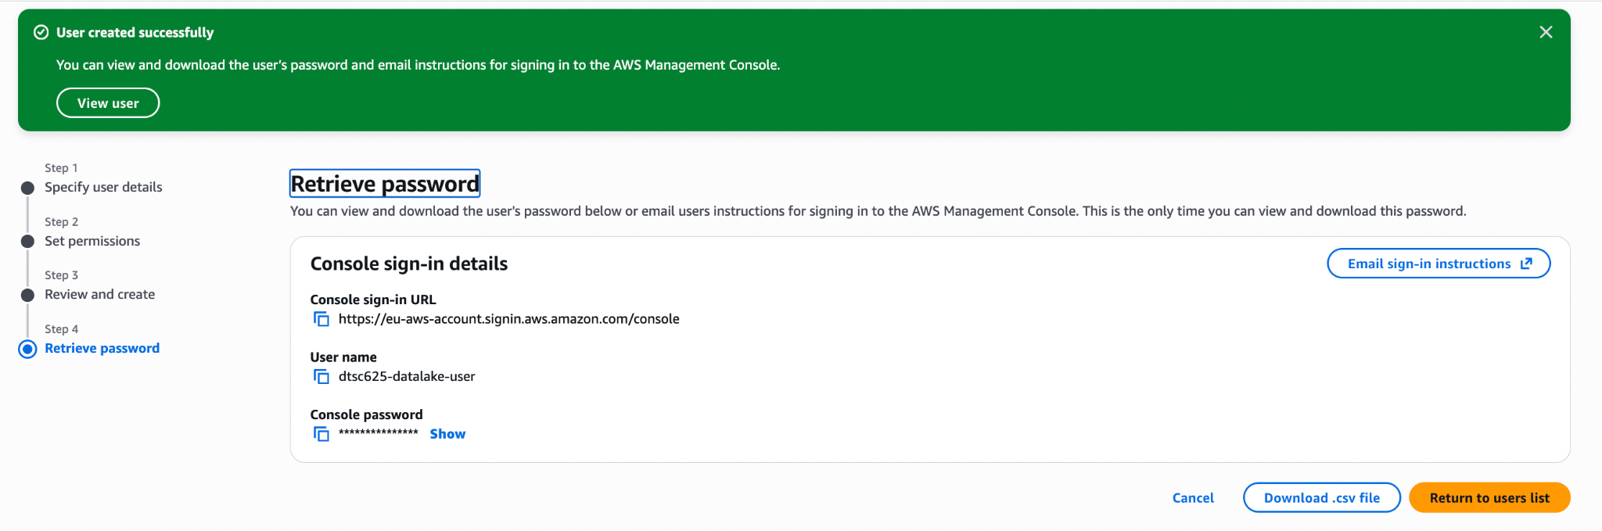

- If you think you might forget the password you chose, you can download this information as a CSV.


Step 5: Verify the IAM User has Access
We can now verify that our new datalake-user has access to dtsc625-labs database and that the user can run Athena queries on the table in this database:

- Sign out of the AWS Management Console, and then sign in again using the new user you just created, dtsc625-datalake-user. Use the Console sign-in URL you previously noted down to access the login page.
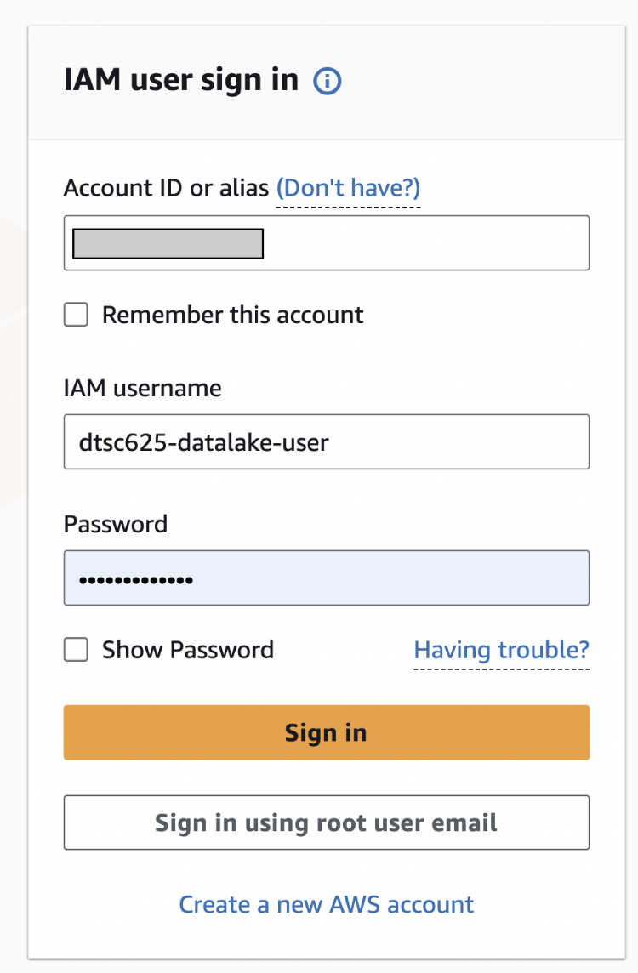

- From the top search bar, search for and select the Athena service.
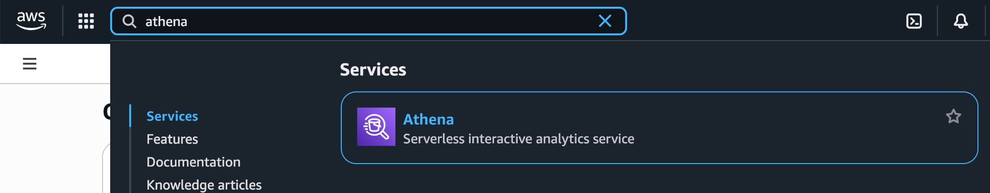

- Before you can run an Athena query, you need to set up a query result location in Amazon S3. This is the S3 bucket and prefix where all the query results will be written to. From the top right of the Athena console, click on Edit Settings.
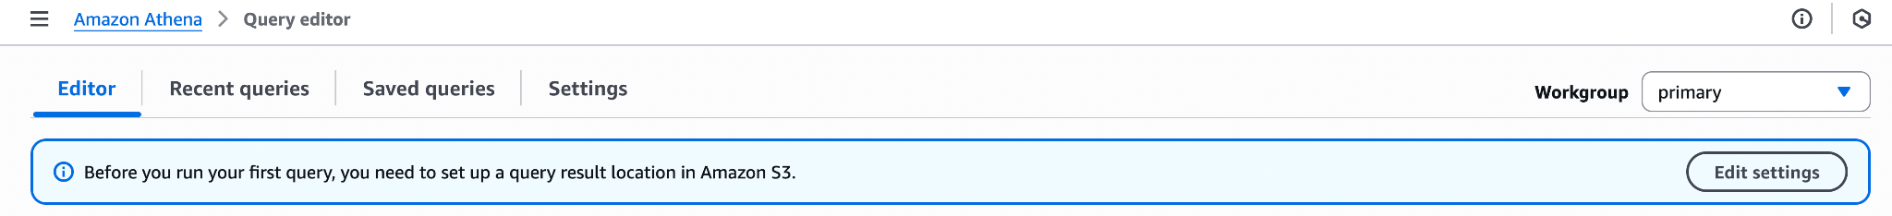

- For Query result location, enter the S3 path you created above (e.g., s3://dtsc625-<lastname>-athena-query-results).
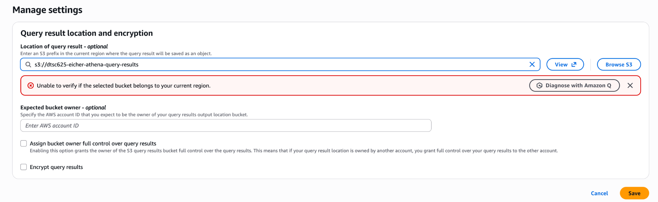
- Although this user does not have permissions to verify the bucket’s location (see red banner below), select Save. You should get a success.
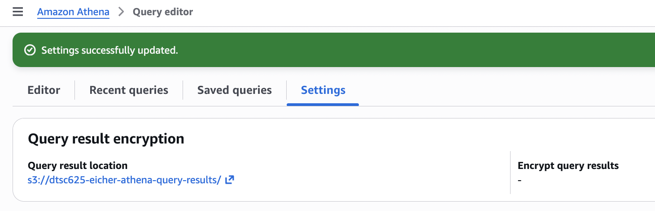
- Change to the Editor tab.
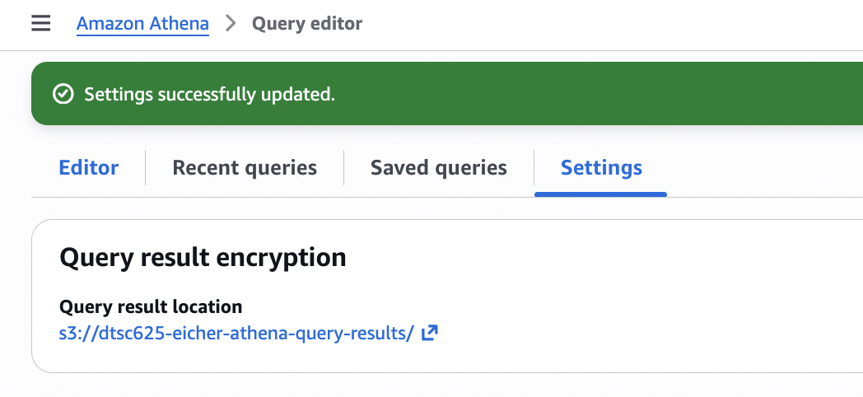

- On the left hand side of the Query Editor, you should see dtsc625-labs under Database, and the fake_company_data listed under Tables. You can expand the Table to see the schema (column names and data types).

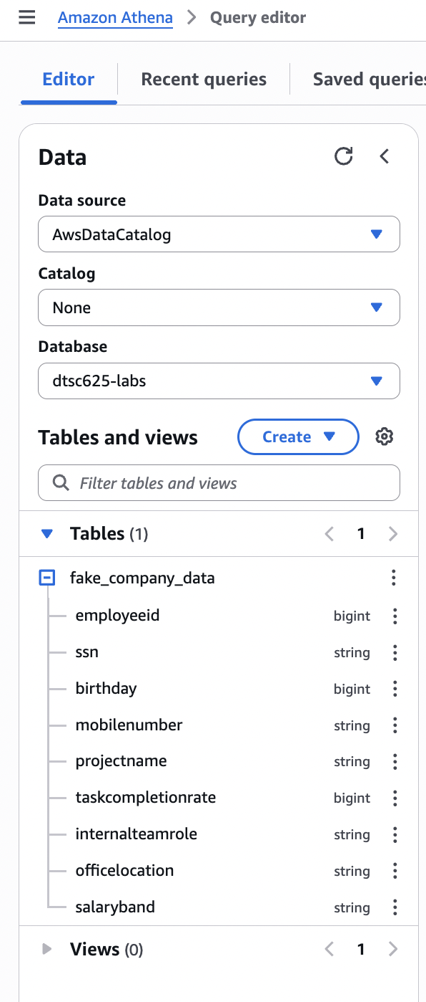
- In the query window, run the following SQL query: SELECT * FROM fake_company_data;
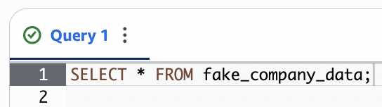

Note: Amazon Athena charges for the amount of data scanned. Given this dataset is very small and we won’t be performing more than a couple queries, charges will be minimal (<$0.01).

- If all permissions have been configured correctly, the results of the query should be displayed in the lower window. The table includes sensitive information, such as social security numbers (ssn), birthdays, mobile phone numbers, and salaryband. The goal of this lab is to hide this information from the data-lake user!
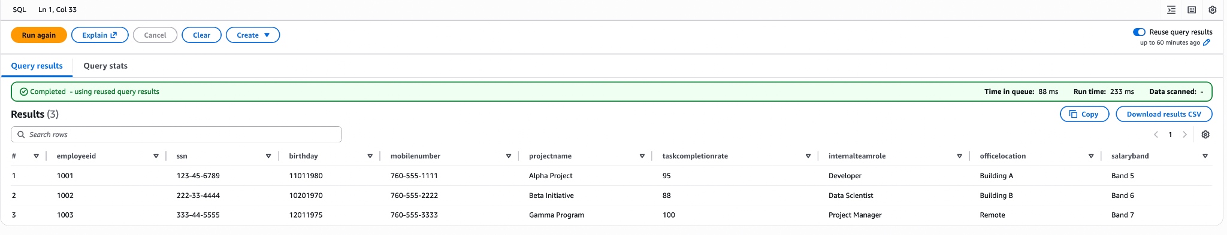

- Select “Reuse query results” to save on unwanted charges, in case you perform multiple identical queries.
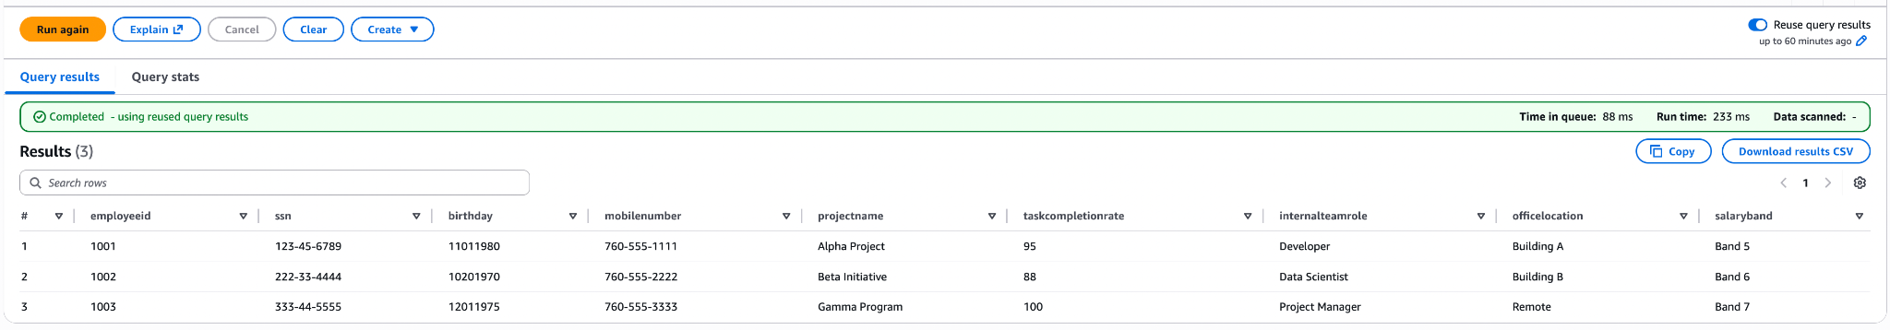

We have verified that the data-lake user has access to the database and table. We want to hide columns with sensitive data, which we cannot accomplish with IAM permissions. Instead, we need a new service–LakeFormation–to accomplish this.

- Log out of the AWS Management Console since we need to be logged in as our regular user, not datalake-user, for the next steps.

Step 6: Activating Lake Formation Permissions
In the initial setup, we configured permissions for our data lake user to be able to run SQL queries using Amazon Athena, and we restricted their access to just dtsc625-labs database using an IAM permissions policy.

In this section, we are going to modify dtsc625-labs database and the tables in that database to make use of the Lake Formation permissions model.

Lake Formation adds a layer of permissions that work in addition to the IAM policy permissions. By default, every database and table in the catalog has a special permission enabled that effectively tells Lake Formation to just use IAM permissions and to ignore any permissions that may have been granted in Lake Formation. This is sometimes called the Pass-Through permission, as it allows security checks to be validated at the IAM level, but then passes through Lake Formation without doing any additional permission checks.
With our initial setup, we granted Glue Data Catalog permissions to datalake-user in an IAM
policy. This policy allowed the user to access the dtsc625-labs database, as well as all the tables in that database. Let’s have a look at how permissions are set up on the dtsc625-labs database and tables in Lake Formation:

- Log in to the AWS Management Console and search for the Lake Formation service in the top search bar. Make sure you are logged in as your regular user, and not as datalake-user, which you created earlier in this lab.
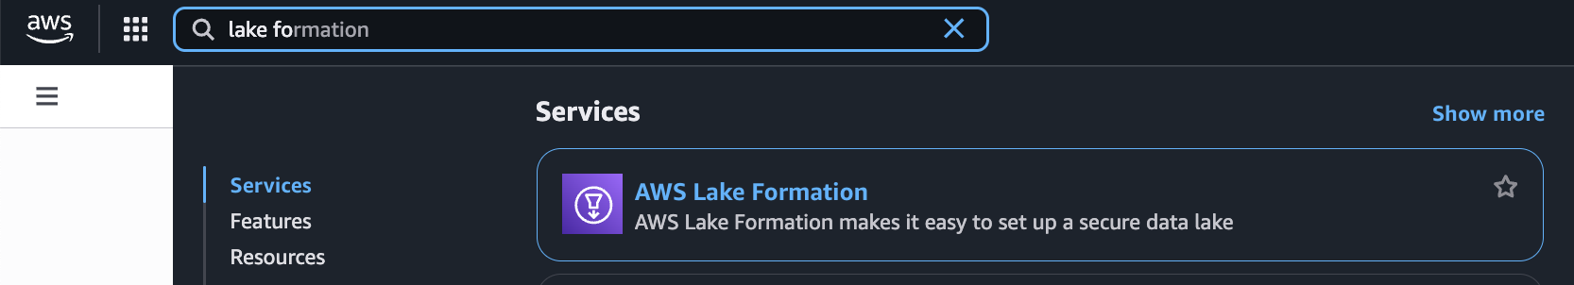

Note: The first time you access the Lake Formation service, a pop-up box may prompt you to
choose initial users and roles to be Lake Formation data lake administrators. By default,
“Add myself” should be selected. Click Get started to add your current user as a data lake
admin.

- Once selected, you should be taken to the Lake Formation Data lake administrators screen, where you can confirm that your user has been added as a data lake administrator. If you see your user listed, skip to Step 7 in this lab.

- If you do not see your user, go to “Administrative role and tasks”, and click on the right “Add”.
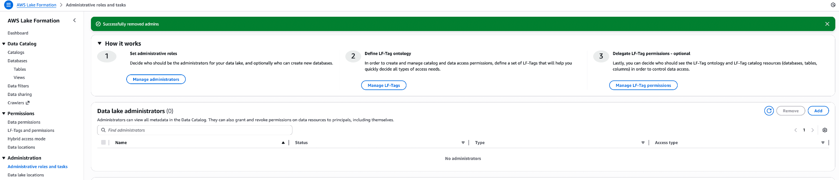

- Make sure “Data lake administrator” is selected, and find your user name and select it. Then click Confirm.
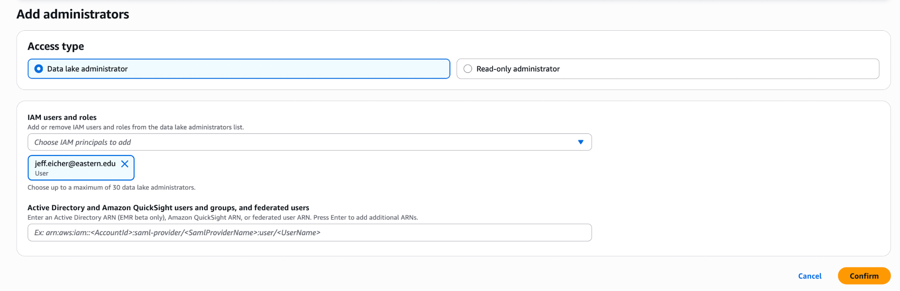

- You should now see your user as a data lake administrator.
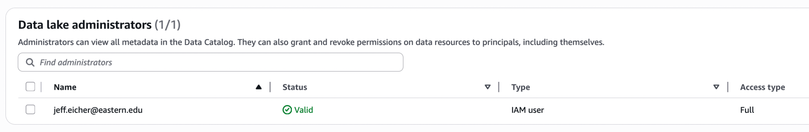

Step 7: Granting Lake Formation permissions
By removing the IAMAllowedPrincipals permission from the dtsc625-labs database and the
PII table, we have effectively enabled Lake Formation permissions on those resources. Now, if any principal needs to access that database or table, they need both IAM permissions, as well as Lake Formation permissions.

- On the left-hand side of the Lake Formation console, click on Databases. In the list of databases, click on the dtsc625-labs database.
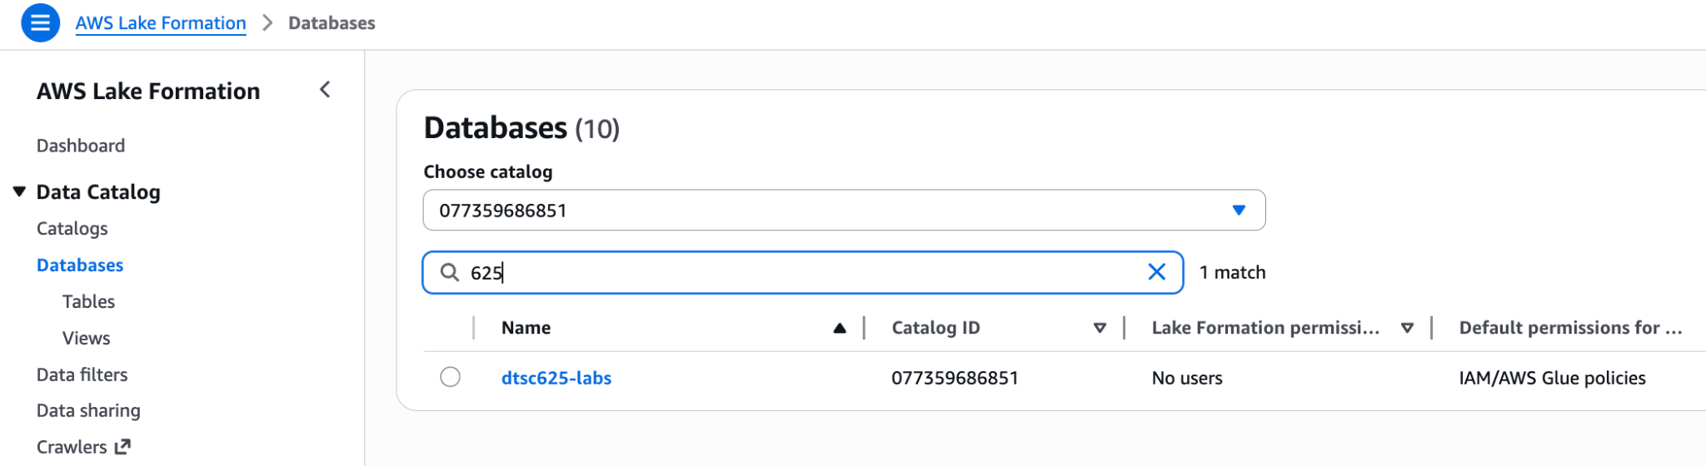

- This screen displays details of dtsc625-labs. Click on Actions, and then under Permissions, View.
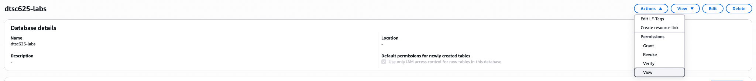

- Select the dtsc625-csv-to-parquet-S3-glue-role (or dtsc625LambdaRole-S3GlueCloudWatch) and select Grant.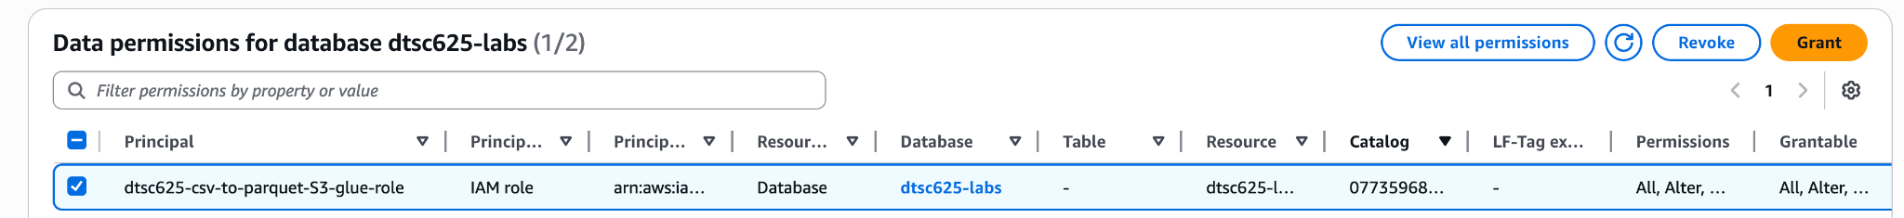

- Leave the defaults “Principals” and “IAM users and roles” selected. Under “IAM users and roles,” select the dtsc625-datalake-user user.
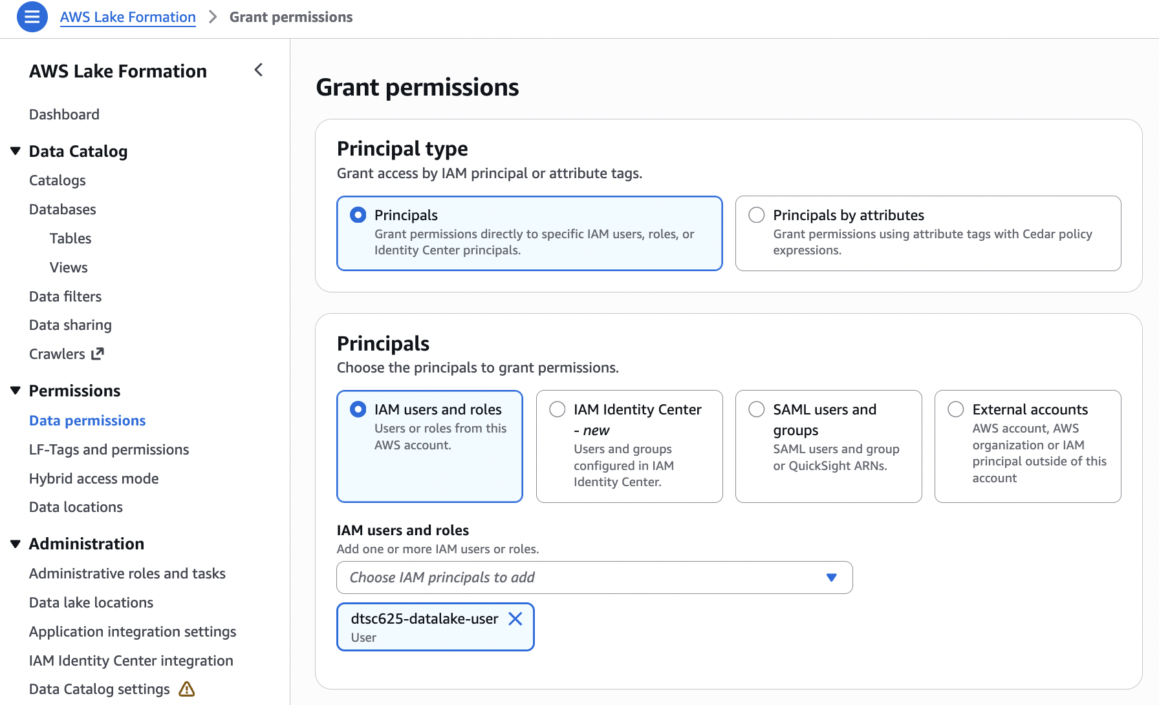

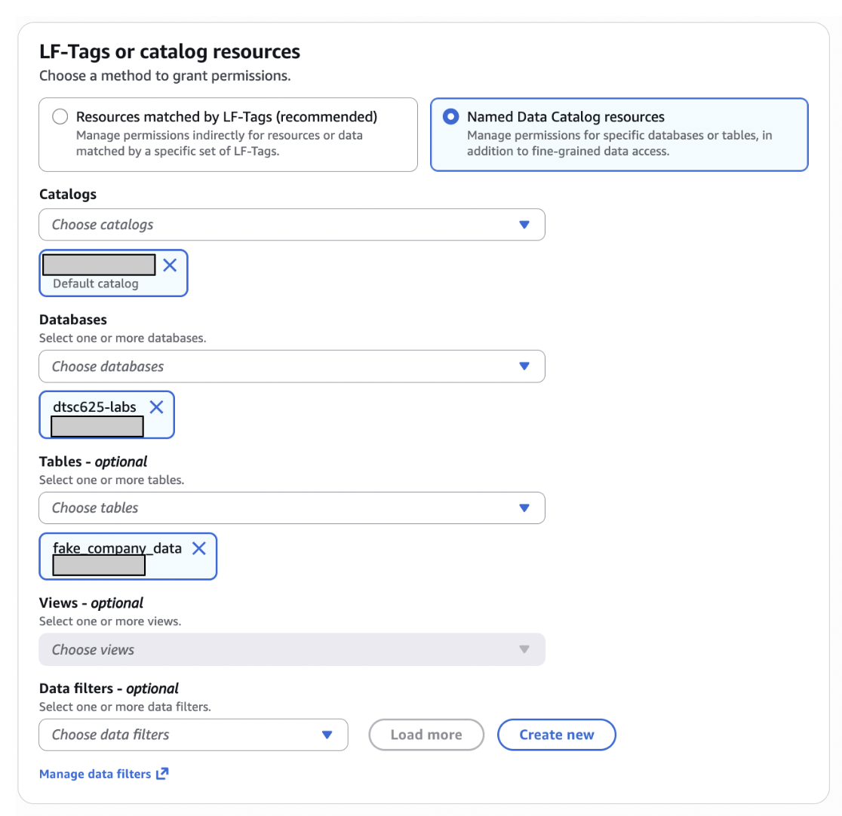
- Under LF-tags and catalog resources, select “Named Data Catalog resources.” Select the default catalog. Then select the database (dtsc675-labs) and the table (fake_company_data) you want the datalake-user to have access. Notice that you can select which specific tables in a database you want the datalake-user to have access to, which is a great feature, in case you have sensitive data stored in a particular table.

- Under Data Filters - optional, select Create new.
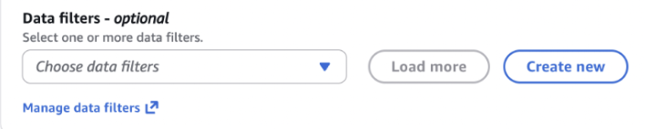
- Give the filter a name, like RemovePII, select “Exclude columns” and select birthday, mobilenumber, salaryband, and ssn. Click Create filter.
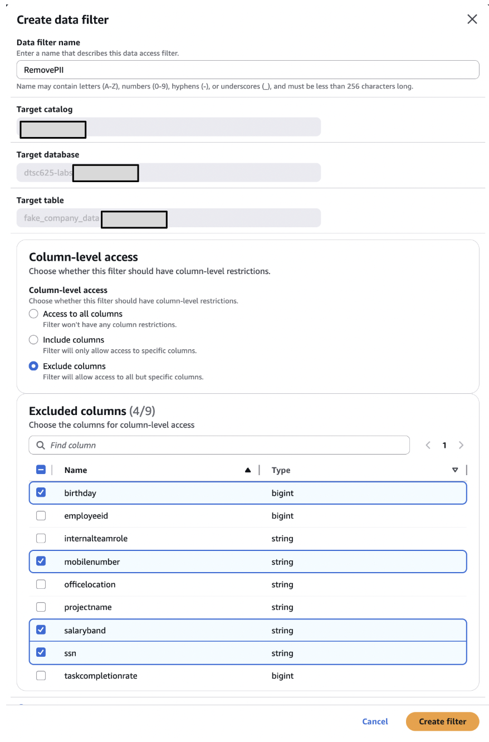
- Under Data filter permissions, check the box “Select”.
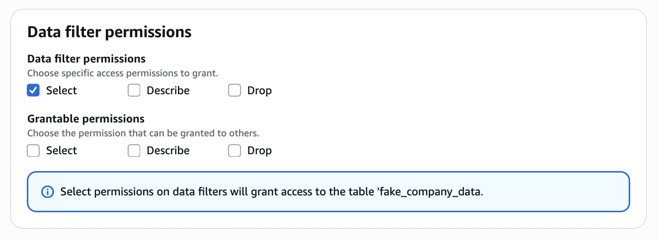
- Select Grant.

Lastly, we must revoke the datalake-user permissions as part of the IAMAllowedPrincipals group. This is the pass-through permission, which means that permissions at the Lake Formation layer are ignored and the datalake-user will still be able to see the PII in the table.

- Select Data permissions in the left hand menu, then search and find the IAMAllowedPrincipals for the table fake_company_data. Click Revoke.
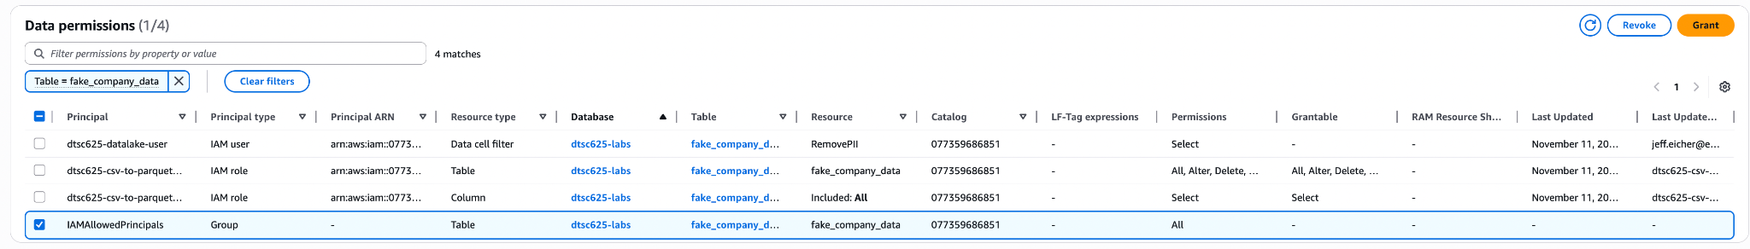

Step 8: Verify Hidden PII for datalake-user
In the preceding steps, we put in a column limitation, which means that datalake-user will not be able to access the columns with PII. Enabling column-level permissions is not something that would be possible if we were just using IAM-level permissions, as column-level permissions is a Lake Formation-specific feature.

Earlier in this lab, recall that our Athena query results showed sensitive data from a company’s employees.
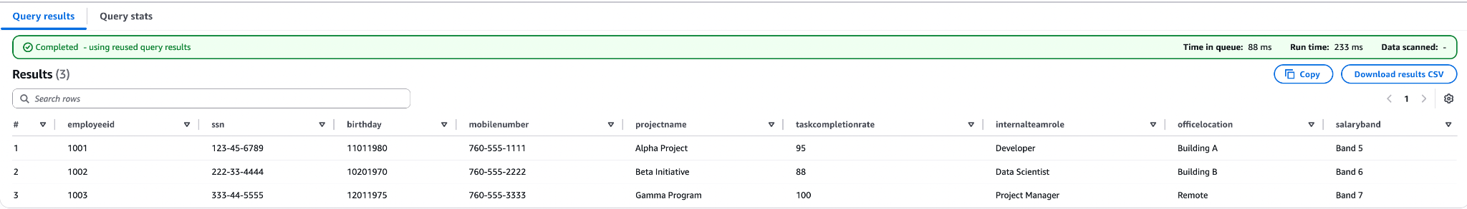

Let us now verify that the Lake Formation permissions have taken effect.

- Sign out of the AWS Management Console, and then sign in again using the new user you just created, dtsc625-datalake-user. Use the Console sign-in URL you previously noted down to access the login page.

- Navigate to Athena and perform the earlier query. Your results should have fewer columns now, where none have PII:
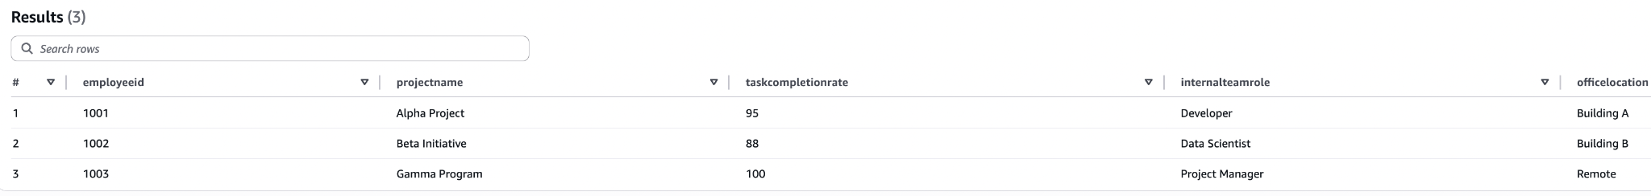

Step 9: Brightspace submission
- Make a copy of the assignment template (File > Make a copy) to fill in your answers and add screenshots. Download your completed template as a PDF Document to submit here.

